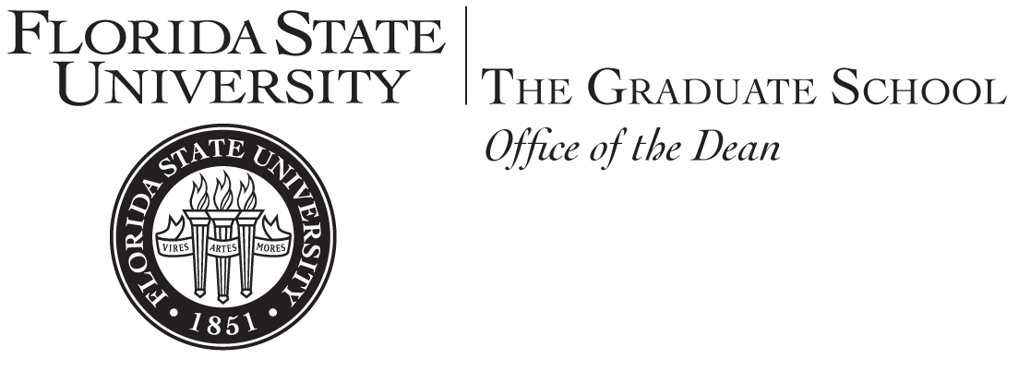

MEMORANDUM

To: Graduate Program Directors and Graduate Enrollment Management Committee Members

From: Brian Barton, Associate Dean

Date: April 23, 2020

Subject : Fall 2020 GRE and GMAT Waivers

I know this is a long memo, but it contains vitally important information. Please read it carefully, and then pass it along to any and all staff in your college that may need this information. As I explain below, this will go into effect today.

The Graduate School has been continuously monitoring the COVID-19 crisis and the impacts it is having to graduate enrollment. Our office has been monitoring the various committees on campus for continuity of operations, non-FSU professional organizations, and other universities for information related to enrollment. In the past two weeks we have been involved with virtual meetings with the Association of International Educators (NAFSA), The Council of Graduate Schools (CGS), and the Educational Testing Service (ETS) to find out the latest information regarding graduate enrollment.

While our Fall 2020 admissions numbers are still strong, we must try and do everything we can to offset any potential enrollment shortfall we could suffer from the lingering impacts of COVID-19 travel restrictions etc. Additionally, we need to bring-in as many self-paying master’s students as possible.

While ETS and the GMAC have rolled-out online test at home options for the TOEFL, GRE, and GMAT, it is clear that the GRE online testing process leaves many roadblocks for applicants. Examples of this are: it cannot be done via Mac or tablet, test takers can have no one in the room, and there are other software/microphone/camera requirements that may be roadblocks for many students.

With all of these items in mind, the Graduate Policy Committee and Faculty Senate have approved a GRE and GMAT waiver for the Fall 2020 term for Master’s and Specialist applicants only.

Since the April 15th CGS resolution deadline for making financial offers to graduate students has passed, this should have little disruption to your current process for funded students. This will apply to current and future master’s applicants for the Fall 2020 term. On April 23rd the Graduate School will waive any required test scores on all Master’s applicant checklists currently in Slate. Once the process is complete, the Graduate School will send all applicants that are missing unofficial and/or official scores an email notifying them of this university waiver. For all students that start an application after April 23rd, we will automatically apply this waiver to the applicant’s checklist within Slate.
This waiver will not apply for doctoral applicants, however, there is a mechanism already in place. Under the Graduate Policy Committee (GPC) rules programs with approved GRE waivers in place can continue to offer these waivers. Programs that do not have waivers approved by the GPC, but want to waive the GRE for doctoral applicants, may do so if it is approved by the Academic Dean on a student-by-student basis.
The Enrollment Team will be sending out marketing to prospects and applicants to notify them of this change/opportunity and we encourage your departments to market this as well. Reach out to the enrollment team at grad-help@fsu.edu if you need any help with communicating to a particular student. Please let me know if you have any questions.

We will market this waiver announcement across several mediums and populations including FSU undergraduates who are graduating before fall, a press release, and the More in Four population. Additionally, we have developed a new webpage to provide info to prospective applicants https://gradschool.fsu.edu/prospective-students. Also, we will be launching a multi-phase web and social media marketing campaign from Pensacola to Jacksonville down to Orlando and Tampa to advertise this waiver in an effort to increase applications.

We are also sending a memo to all Deans and Graduate Department Representatives that work with the Enrollment Team to let them know of this change.

Finally, I would ask that you encourage all of your units to accept as many qualified self-paying Master’s and Specialist students you can for this fall to make sure our enrollment and credit hour projections stay steady to help our revenue situation.

